Domestic Abuse Conference
Weds 24th November 2021
9.30 to 2.15pm

“When staff experience Domestic Abuse in their own lives…”

The event will be held virtually
Register in advance for this webinar:
https://us02web.zoom.us/webinar/register/WN_QSw5OMKuTJ27CMfiafpj8w

After registering, you will receive a confirmation email containing information about joining the webinar.
Time | Topic | Speaker
9.30am Introduction to the conference and theme for the day
Susan Bray, Named Professional for Safeguarding Children/Domestic Abuse Lead (chair).

9.35am | Welcome to the day | Claire Murdoch  Chief Executive, CNWL NHS Foundation Trust
9.45am | Update on the work of the Domestic Abuse Commissioner – Key Developments and Challenges | Nicole Jacobs  Designated Domestic Abuse Commissioner for the UK
10.05am | Victims of Domestic Abuse Working within a Health Setting. | Kate Davies  CBE, Director of Health & Justice, Armed Forces and Sexual Assault Referral Centres (SARCs)
10.25am | Survivor Story
10.40am Panel Question and Answer Session
10.55am Break

11.15am | Identifying and Supporting Perpetrators within a Work Setting | Joanna Szuryn,  Regional Practice Lead (Training and Diversity) for Make a Change, Respect  Rebecca Vagi  National Lead for Make a Change, Respect
11.35pm | What to do when Victims/Perpetrators Work in the Same Organisation? | Chantal Hughes  Chief Executive Officer  Hampton Trust
11.55am | Perpetrator Story
12.15pm Panel Question and Answer Session
12.30pm Break

12.50pm | How do we support staff as a Trust?  Trauma-informed approaches to Domestic Abuse. | Dr Ryan Kemp  Director of Therapies, CNWL NHS Trust  Annabel Butcher  Head of Corporate HR,  CNWL NHS Trust
1.20pm | Working title TBC | Jess Phillips  Shadow Minister for Domestic Violence
1.40pm | Survivor Story
1.55pm Panel Question and Answer Session
2.10pm Closing words (Catherine Knights)
2.15pm End of conference (Chair – feedback/ambassador role/going
Forwards)

Speaker biographies

Nicole Jacobs, Designate Domestic Abuse Commissioner



Nicole began her career at the Alabama State Coalition Against Domestic Violence in the United States. In 1999, she came to London as an Independent Domestic Violence Advocate at ADVANCE, one of the first advocacy services in the UK. She began working at Standing Together Against Domestic Violence (STADV), focussing on the coordinated community response to domestic abuse. In 2013, Nicole became the CEO of STADV. She oversaw substantial growth, headed up strategy development, and expanded the influence of STADV via national programmes of work.
Since her appointment to the role of Designate Domestic Abuse Commissioner in September 2019, Nicole has used her 20 plus years of experience in domestic abuse policy and intervention to transform the response to domestic abuse. She is committed to championing victims and survivors of all ages, status, and backgrounds, and to shining a light on practises that fail them.
Her areas of focus include public leadership on domestic abuse issues, overseeing and monitoring the provision of domestic abuse services across England and Wales. Since April 2021, when the landmark Domestic Abuse Act became enshrined in statute, she has been furnished with specific legal powers that enhance her ability to make recommendations to national and local government, statutory agencies and third sector organizations on how to improve their response to domestic abuse.

Kate Davies CBE, Director of Health and Justice, Armed Forces and Sexual Assault Services Commissioning, NHS England and NHS Improvement
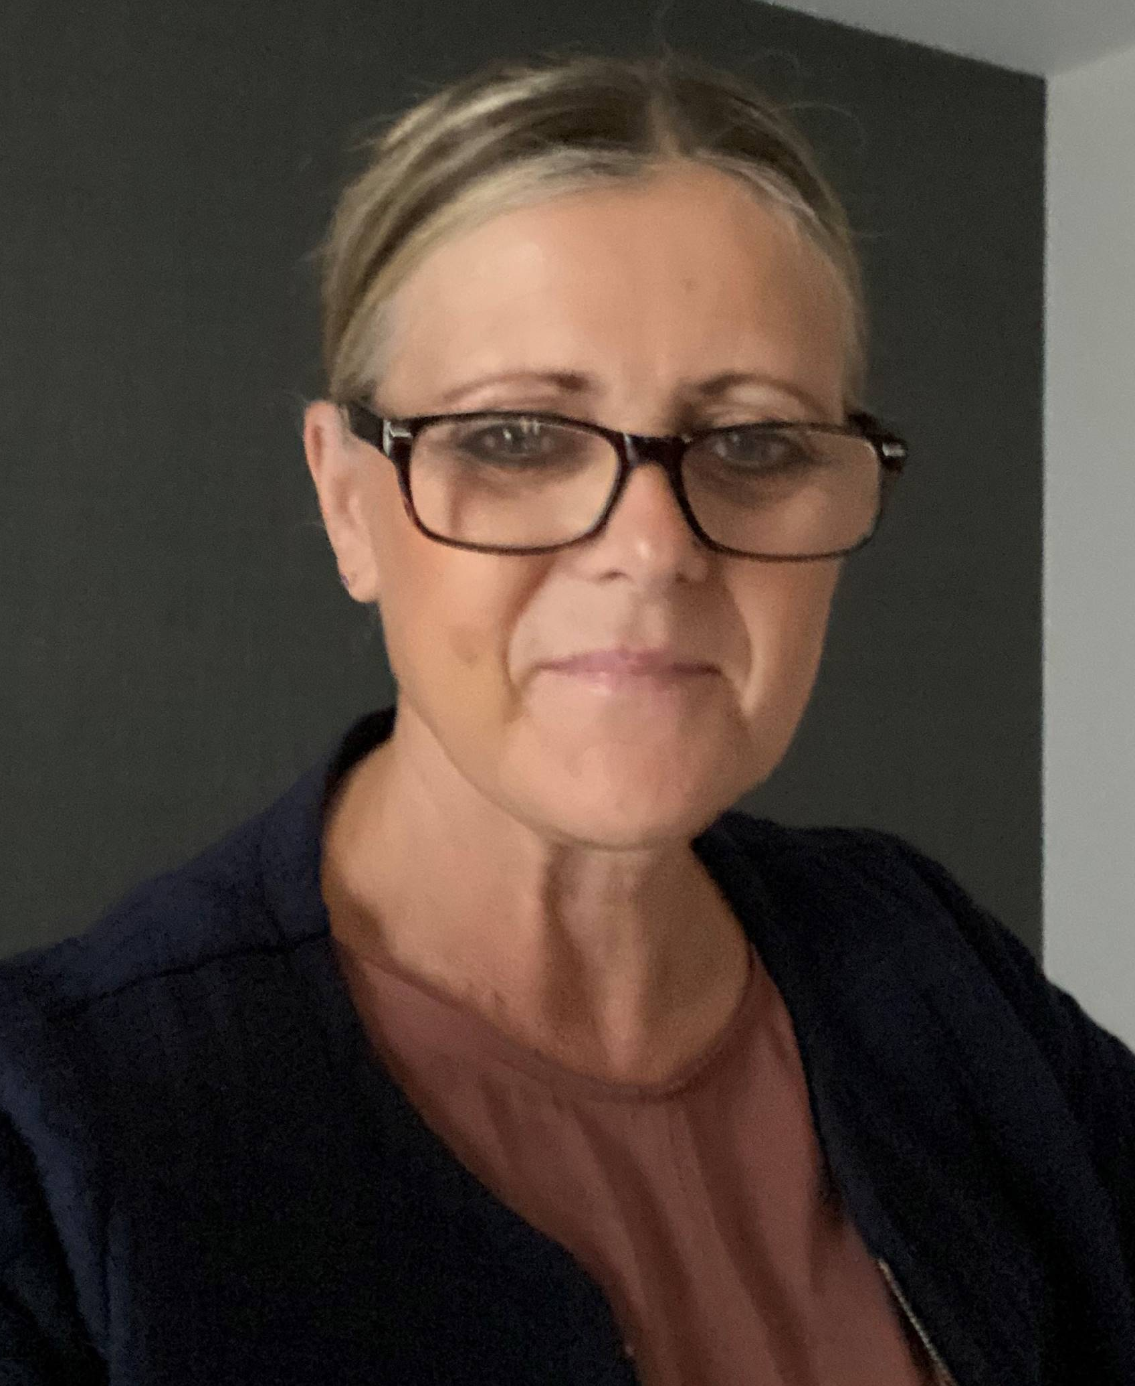
Kate is the national director for healthcare services across England for Armed Forces serving personnel, veterans and their families; sexual assault referral centres (SARCs); and prisons, immigration removal centres and secure children’s homes and training centres. Her national role is to assure high quality, consistent and sustained services with a strong focus on health inequalities and outcomes for patients and their families.

Kate has developed and led national partnership agreements with the Ministry of Defence for Armed Forces commissioning, the Ministry of Justice for prisons and the children and young people secure estate and the Home Office for immigration removal centres. These agreements focus on core objectives and outcomes across Government for key patient areas that can only be delivered in partnership.

From a health and justice perspective, she has led the development of the national Liaison & Diversion Programme and Street Triage, the roll out of community sentence treatment requirements and the launch of RECONNECT to support prison leavers transition to community health and wellbeing services. Kate has facilitated the roll-out of increased provision for survivors of sexual violence, the launch of the Strategic Direction for Sexual Assault and Abuse Services and the development of enhanced sexual assault and abuse pathfinder services for individuals with complex trauma mental health needs.

Prior to her current role, Kate worked in a range of senior positions, including the Executive Lead for Prison, Detainee and SARCs Healthcare Commissioning for East Midlands; the strategic director of the award-winning Nottinghamshire County Drug and Alcohol Action Team, where she co-ordinated and delivered the Government’s National Drug Strategy; and the Director of Black and Ethnic Minority Community Engagement at the University of Central Lancashire, International School for Communities Rights and Inclusion. This follows her early career, when she worked as a probation office in the probation service.

In addition, Kate has been a Non-Executive Director on the National Treatment Agency Board and a member of the Government’s independent Board for the Prison Drug Treatment Strategy Patel Review, which implemented the Substance Treatment Service and strategy and delivery across England. She has also been an Ambassador for Diversity in Public Appointments for the Government Public Appointments Commission.

Kate’s strong leadership style and commitment to lived experience, co-production and addressing health inequalities, has led to her being awarded an OBE in 2009 for services for disadvantaged communities and a CBE in 2018, for her work to improve services for some of the most vulnerable groups. She is also an Honorary Doctor of Staffordshire University in recognition of her commitment to health and social equality.

Joanna Szuryn, Regional Practice Lead for Training and Diversity for Make a Change, Respect

Prior to joining Respect in 2021, Joanna spent almost a decade delivering individual and group support and managing various ‘whole family’ domestic abuse projects in community, education and social care settings. Joanna is a qualified Independent Domestic Violence Advisor and a trained Domestic Homicide Review chair. Joanna is also an accredited Adult and Children and Young People Recovery Toolkit facilitator and holds a level 2 certification in Narrative Practice. Joanna’s previous professional background is teaching, training and international business development. Joanna is fluent in Polish and German.

Rebecca Vagi, National Lead for Make a Change, Respect

Since 2008, Rebecca has worked in the field of gender- based violence, delivering and managing frontline services for women and children, co-ordinating local community responses to domestic abuse in health and housing settings and worked with organisations to develop in-house interventions to enhance how they deliver services to survivors and children. In previous roles, Rebecca was the Programme Manager of the Whole Housing approach project at Standing Together and prior to that the Development Lead at Women’s Aid Federation of England for the Change that Lasts Project. She also led on a project with the South East Coast Ambulance Service to establish a Domestic Abuse response within the Trust which was the first of it’s kind within an ambulance service.

Chantal Hughes, CEO, Hampton Trust
Chantal has worked in the voluntary sector for over 20 years. She started her career working with young people in care and delivering National Children’s Bureau training to equip individuals to provide mentoring support to careleavers. She has held posts with The Children’s Society where she developed services for sex workers, looked after children, careleavers and young people in the criminal justice system. Her career has involved designing a range of experiential courses and interventions aimed at breaking the cycle of abuse, offending and exploitation.
Chantal taught Psychotherapy at University of Southampton for six years, whilst holding various psychotherapy posts, including schools based work, private practice and six years working with Relate, during which time she assisted in the implementation of the ‘bridging to safety model’ for couples experiencing domestic abuse.
Chantal joined Hampton Trust in 2006 as the Domestic Abuse Services Manager before progressing to Deputy Chief Executive. She took a 4-month sabbatical in 2011 to work for a charity providing rehabilitation to street children in one of the largest slums in Africa and remains connected to the work in Kenya.
Taking up the role of CEO in 2013, Chantal has led the expansion of a range of domestic abuse and criminal justice interventions. She remains firmly committed to tackling the root cause of domestic abuse by holding perpetrators to account and ensuring the voice of victims and children are at the forefront of the work.

Ryan Kemp, Director of Therapies, CNWL

Biog to follow.

Annabel Butcher, Head of Corporate HR, CNWL

Biog to follow.

Jess Phillips, Shadow Minster for Domestic Violence

Jess Phillips is a Labour Party politician who became the MP for the constituency of Birmingham Yardley at the 2015 general election.

Jess has committed her life to improving the lives of others, especially the most vulnerable. Before becoming an MP, Jess worked for Women’s Aid in the West Midlands developing services for victims of domestic abuse, sexual violence, human trafficking and exploitation. She became a councillor in 2012, in this role she worked tirelessly to support residents, with her work being recognised when she became Birmingham's first ever Victims Champion.

Since becoming an MP, Jess has continued her fight to support those who need it the most and has earned a reputation for plain speaking since being elected, unfazed by threats and calling out sexist attitudes as she promotes women’s rights and focuses on ending violence against women and girls and on issues of justice and home affairs.

Jess is a bestselling author and has written three bestselling books. Her books focus on demystifying the worlds of politics and activism to encourage others to take back power and control.

