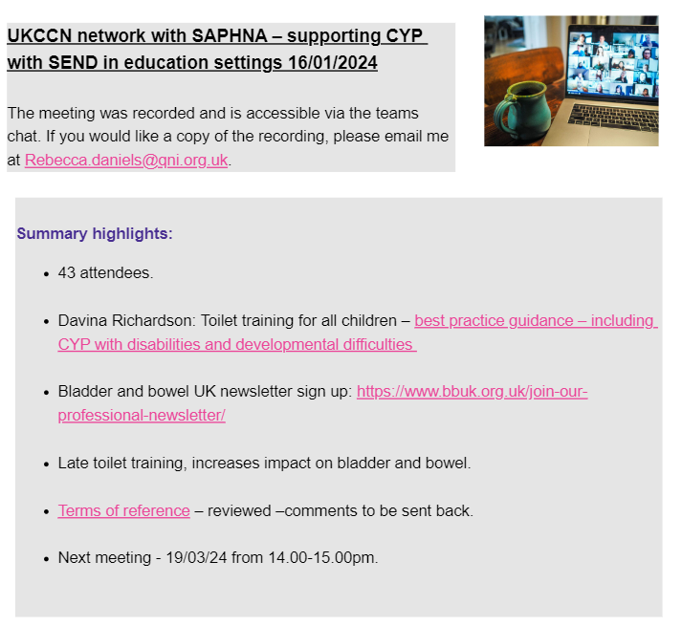

Upcoming dates meetings:

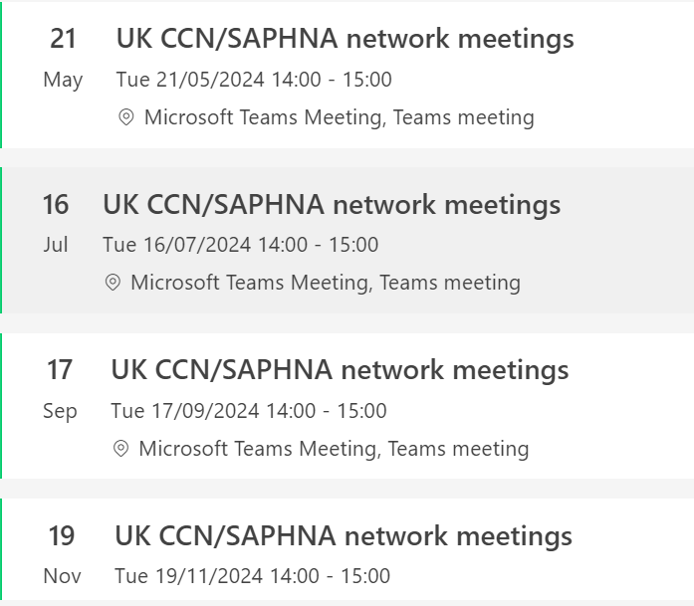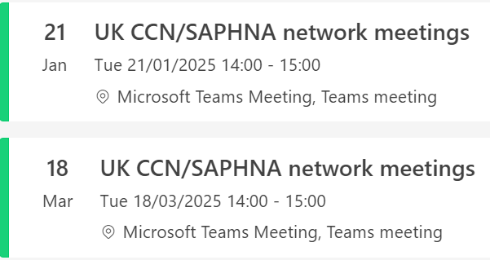

Microsoft Teams meeting

**Join on your computer, mobile app or room device**

[Click here to join the meeting](https://gbr01.safelinks.protection.outlook.com/ap/t-59584e83/?url=https%3A%2F%2Fteams.microsoft.com%2Fl%2Fmeetup-join%2F19%253ameeting_YjZkMzZmMTgtNTkyOS00MWNjLWI2ZWYtZmYyYzhlNDc3N2U5%2540thread.v2%2F0%3Fcontext%3D%257b%2522Tid%2522%253a%252237c354b2-85b0-47f5-b222-07b48d774ee3%2522%252c%2522Oid%2522%253a%2522df64abd0-95b8-4a4b-944e-58d2fec3e6d2%2522%257d&data=05%7C02%7Crebecca.daniels%40qni.org.uk%7Ca8c767b870914da435c308dc0085c2e9%7C7222141219b84a0ea17866f73247c5b2%7C0%7C0%7C638385821714770096%7CUnknown%7CTWFpbGZsb3d8eyJWIjoiMC4wLjAwMDAiLCJQIjoiV2luMzIiLCJBTiI6Ik1haWwiLCJXVCI6Mn0%3D%7C3000%7C%7C%7C&sdata=XCgq%2FC6RXQtVXlQBH30ka4Zfx2DxGb101LeUiLV59bk%3D&reserved=0)

Meeting ID: 388 743 988 429

Passcode: MjxiZU

[Download Teams](https://gbr01.safelinks.protection.outlook.com/?url=https%3A%2F%2Fwww.microsoft.com%2Fen-us%2Fmicrosoft-teams%2Fdownload-app&data=05%7C02%7Crebecca.daniels%40qni.org.uk%7Ca8c767b870914da435c308dc0085c2e9%7C7222141219b84a0ea17866f73247c5b2%7C0%7C0%7C638385821714770096%7CUnknown%7CTWFpbGZsb3d8eyJWIjoiMC4wLjAwMDAiLCJQIjoiV2luMzIiLCJBTiI6Ik1haWwiLCJXVCI6Mn0%3D%7C3000%7C%7C%7C&sdata=DSgGUZ8tBf%2BcW6i%2F26PBLbI9QFr5US6V4AtAUU47Nxo%3D&reserved=0) | [Join on the web](https://gbr01.safelinks.protection.outlook.com/?url=https%3A%2F%2Fwww.microsoft.com%2Fmicrosoft-teams%2Fjoin-a-meeting&data=05%7C02%7Crebecca.daniels%40qni.org.uk%7Ca8c767b870914da435c308dc0085c2e9%7C7222141219b84a0ea17866f73247c5b2%7C0%7C0%7C638385821714770096%7CUnknown%7CTWFpbGZsb3d8eyJWIjoiMC4wLjAwMDAiLCJQIjoiV2luMzIiLCJBTiI6Ik1haWwiLCJXVCI6Mn0%3D%7C3000%7C%7C%7C&sdata=RnVDweDwt%2FwbkXFovywHNch6lIKvo%2FjdZAdXCXedayg%3D&reserved=0)

Summary highlights 19/3/24 (9 attendees)

* NGT feeding in the community <https://journals.rcni.com/nursing-children-and-young-people/evidence-and-practice/checking-nasogastric-tube-safety-in-children-cared-for-in-the-community-a-reexamination-of-the-evidence-base-ncyp.2024.e1493/abs>
* Blends Study day - <https://wilbosblends.co.uk/events-1/event-one-lbrhg> 14th May, Manchester open for registrations currently

Measles

* <https://assets.publishing.service.gov.uk/media/65ddd0e9f1cab3001afc4774/national-measles-guidelines-Feb-2024.pdf>
* <https://www.gov.uk/government/publications/national-measles-guidelines/measles-factsheet>

EHCP

* Open discussion regards information regards training, number staff per year, expectations
* Online training for outcomes <https://councilfordisabledchildren.org.uk/what-we-do/e-learning>
* <https://councilfordisabledchildren.org.uk/resources/all-resources/filter/inclusion-send/education-health-and-care-plans-examples-good-0>

Safeguarding children with SEND

* <https://learning.nspcc.org.uk/safeguarding-child-protection/children-who-have-send-asn-aln>
* <https://www.maddiesonline.com/> - generalised online safety

Open space

* Models of SSN teams – discussion on remodelling, refining boundaries and cross working across schools, including remote ways of working and team working to cover schools.

Request for information:

**Supporting Children and Young people with health needs in education settings. Can you share information/case studies on the below pleas**e:

1. **Sharing good practice –** please can you email Andrea  [andrea.ferns2@nhs.net](mailto:andrea.ferns2@nhs.net) with any examples of good practice we can share with the group.
2. **Sharing gaps in provision -** please can you email Andrea  [andrea.ferns2@nhs.net](mailto:andrea.ferns2@nhs.net) with any examples of gaps in health provision that we can use as evidence to support further discussions at National Level
3. **CYP not accessing education** – please can you email Andrea  [andrea.ferns2@nhs.net](mailto:andrea.ferns2@nhs.net) with examples of anonymised case studies where CYP are not able to access education as their clinical intervention needs are unmet.